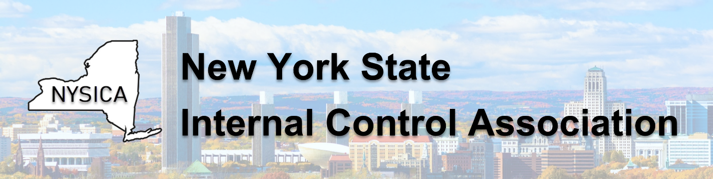
REGISTRATION NOW OPEN
2026 NYSICA FALL CONFERENCE
WEDNESDAY, SEPTEMBER 16, 2026
Hudson Valley Community College | Troy, New York | 8:00 a.m.–4:00 p.m.
Please join us as we welcome internal control professionals from across New York State for a full day of practical insight, emerging approaches, and professional connection.

PROGRAM PREVIEW
8:30am–12:00pm | Enterprise Risk Management: Where’s the Value?  Corey Gooch and John Bugalla | Risk Solutions International
1:30–2:30 pm | Recruiting, Retention, Succession Planning, and Adapting to Workforce Performance Management  Jessica Rowe, Deputy Commissioner | NYS Department of Civil Service
2:45–4:00 pm | Fraud Risk Assessment: A New Model and New Approach  Leonard Vona | Fraud Auditing, Inc.

REGISTRATION
$125 NYSICA members | $140 non-members
Catered breakfast, lunch, and afternoon snacks included
CLICK HERE TO REGISTER

